Here is some training material that can be sent to anyone requesting additional information.

Competition: There will be two mock interactions.

1. Media – the contestant will participate in a mock media interview. The interviewer will ask pre-determined questions with the option to ask follow-up questions. A panel of judges will observe the interaction for knowledge, articulation, poise and the contestant’s ability to explain beef production and present the beef community in a positive manner. Your understanding of some of the general information about how cattle are raised, cared for and good for you will be extremely helpful. The judges will be looking for you to share your story whether you raise cattle or not. Just your knowledge of beef and how it affects your life. You may just like to eat it and that is OK. Then your focus will be on nutrition and how to cook it to a safe temperature for eating. Life ground beef is safe and savory at 165 degrees. Knowing what a beef advocate is will be helpful. On a national level ANCW has a Collegiate Beef Advocacy Program and by competing at the state level you are training to be able to compete for this type of spot:
ANCW's Collegiate Beef Advocacy Program was created for beef industry advocates interested in bridging the gap between the farm and the fork. This program connects the Collegiate leaders to the beef industry where they can have unlimited access to leadership, their peers, cattlemen and cattlewomen and beef industry professionals. They will grow as individuals, strengthen their leadership skills and establish networks.
So an advocate helps to bridge the gap between the farm and the fork. In other words help to show where our food comes from!

2. Peer – A staged conversation between contestant and his/her peer which includes beef production and/or nutrition. A panel of judges will observe each contestant on their ability to relay to their peers appropriate and accurate information regarding beef community and beef nutrition. The same information above applies here; however, this conversation will be more personal versus what you would say to a reporter. These judges will be looking for more in depth answers and a greater comfort level since you are talking to your friends or their parents.

Junior Contestants: Current grade 5th -8th
Senior Contestants: Current grade 9th-12th

Resources or places to review:

Raising Beef (beefitswhatsfordinner.com).
There are several segments within this site that will be helpful. Pay particular attention to "Better Beef" and "Healthier Animals"; however, each of these segments offer great information and tips.

Additional information on nutrition and cuts can be found on the beefitswhatsfordinner.com site

Beef FAQ's (beefitswhatsfordinner.com)

We all know beef tastes great – but did you know that beef can be good for you, too? Check out some answers to your most pressing questions when it comes to beef and your health.

Q: Can beef be enjoyed regularly as part of a healthy, balanced diet?
A: Absolutely! A 3-ounce serving of beef—about the size of an iPhone—provides more than 10 essential nutrients including protein, iron, zinc and vitamins B12 and B6. One serving of beef contains about half of your Daily Value for protein in around 170 calories on average (and just 150 calories for a serving of lean beef).1
Q: How much beef should I eat at a meal to meet my daily protein requirements?
A: Beef is a great protein option and source of essential nutrients to enjoy any day and for any meal! Dietary Guidelines recommend adults eat 5.5 ounces of protein foods, including beef, per day. Beef can be enjoyed for any meal throughout the day so incorporating beef into various meals will help you meet the recommended Dietary Guidelines.2
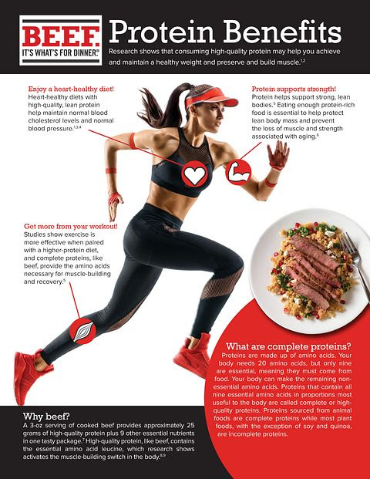

PROTEIN BENEFITS
Q: What benefits do the 10 essential nutrients in beef provide to the human body?
A: High-quality protein, like that found in beef, plays an increasingly important role in muscle maintenance, weight management, and the prevention of chronic diseases. Research also shows the iron, zinc and B vitamins found in beef play an essential role in developing and maintaining cognitive ability in children and adults.3
Q: What nutritional benefits does beef offer me that other proteins don’t?
A: Beef is a nutritional powerhouse in a smaller package than other protein foods. Apart from being a great source of protein, it would take 8 ounces of cooked chicken breast to eat the same amount of iron as in just 3 ounces of beef, and nearly 7 times (20 ounces) the amount of chicken to get the same amount of zinc in a serving of beef!1
Q: Is grass-finished beef more nutritious than grain-finished beef?
A: While grass-finished beef tends to be a little leaner, both grass-finished and grain-finished beef are natural sources of more than 10 essential nutrients including protein, iron and zinc. All cattle, whether grass or grain-finished, spend the majority of their lives eating grass on pastures and provide delicious and nutritious beef.4
Q: Can eating beef help improve cholesterol levels?
A: Yes! Research shows that a heart healthy diet and lifestyle that includes lean beef, even daily, improved cholesterol levels. About half the fatty acids found in beef are called monounsaturated fatty acids, the same kind found in olive oil, and, as part of a heart-healthy diet, can reduce cholesterol levels.1,5
Q: Can plant-based diets and proteins provide the same amount of protein as beef?
A: Many sources of plant protein do not contain all the amino acids your body needs. Beef supplies more protein and nutrients in significantly fewer calories than plant proteins. A lean beef burger patty averages around 154 calories and 25 grams of protein. Conversely, a veggie burger patty may be lower in calories, but only contains 13 grams of protein per serving.1
Q: Can eating beef cause cancer?
A: Cancer is a complex disease and most scientists agree that many factors, including lifestyle and environmental conditions, must be taken into consideration-- making it unrealistic to isolate a single food as a cause of cancer. In fact, despite all the investment made in cancer research, there is no single food, including beef, that has been proven to cause or cure cancer.6
Q: Do higher-protein diets have any negative health effects like kidney damage or bone loss?
A: No, this is a common myth about protein. Eating a diet higher in protein can actually help people lose and maintain a healthy weight and support a healthy metabolism. Research shows that eating 25-30 grams of protein at each meal is ideal for optimal body benefits.7

